OYEZ OYEZ OYEZ! A GUIDE TO DC NEWCOMERS

Introduction

Washington, DC has a wide range of free and cheap things to do throughout the year, from music to food to parks and music. Below, you will find a list of favorite things that compiled by Reedies in the area – all are free unless otherwise noted.

Dining
Reed’s DC Chapter have been doing a monthly restaurant meetup for several years, and have compiled a comprehensive list of all the (relatively inexpensive) restaurants that have been visited. You can view this list here.

Museums
- The Smithsonian museums (17 in DC, most along the mall), including the Portrait Gallery, Air and Space Museum, American Art Museum, and many more, are all free.
- The National Zoo, between Adams Morgan and Cleveland Park.
- The National Gallery of Art on the Mall.

Outdoor/Exercise
- Yoga at Union Market (suggested $5 donation – near NoMa metro)
- DC Public Swimming pools (free for DC residents – bring a utility bill/lease etc.).
- Great Falls Park (northwest of Washington DC - memorable day hike or bike ride with scrambling and scenic views of the water along the C&O Canal).
- Rock Creek Park (in Northwest DC near Columbia Heights – 32 miles of trails for hiking and biking and horseback riding).
- Kenilworth Aquatic Gardens (in Northeast DC, the only national park devoted to cultivated water-loving plants, featuring exotic water lilies and lotuses, with trails for hiking).
- National Arboretum (in Northeast DC, with trees, shrubs, and herbaceous plants cultivated for scientific and educational purposes – including a bonsai and penjing collection. Nine miles of hiking and biking).
- United States Botanic Garden – indoor and outdoor – on the Mall

Free Music
- Kennedy Center’s Millennium Stage (free shows everyday at 6pm).
- Carter Barron Amphitheatre (four free performances in Rock Creek Park)
- Blues Society’s miscellaneous free shows around DC.
- Yards Park Friday Evening Summer Music (free contemporary music performances by Nationals Stadium - only during the summer).
- Jazz in the Garden (jazz shows by National Sculpture Gallery on the Mall - only during the summer).
- Fort Reno Concert Series (eclectic mix of music performances by local punk/indie/alternative bands organized by Discord Records near Tenleytown – only during the summer).
- Bluegrass at Argonaut (Every Thursday at 9:30pm on H St. NE – 21+ and over only).
- Jam at O Street Mansion (Bluegrass/Classical/Americana/ Blues/Gospel jam session every Sunday from 11am – 2pm by DuPont Circle).
- Glen Echo Music and Dance - weekly dances at the Spanish Ballroom, including a dance lesson as part of the admission, which ranges from $8 to $18.
- DC Do-it-Together – Local community organization promoting independent musicians and artists, with many free shows.

Free Film, Theater, and Radio
- Free foreign films many weekends at Freer/Sackler Galleries from the Smithsonian.
- Shakespeare Theater Company free performances.

Farmer’s Markets and Outdoor Food
- Eastern Market
- Union Market
- A list of assorted outdoor markets

Outdoor Movie Screenings

- List of free outdoor movies
- Screen on the Green (on the National Mall – only during the summer)
- NoMa Summer Screen (near Union Station – only during the summer)

Outdoor Festivals – Most happen in the late summer/early fall
- H Street Festival
- Adams Morgan Day
- Columbia Heights Day
- U Street Festival (need link)
- DC State Fair
- Kingman Island Folk and Bluegrass
- Takoma Park Folk Festival
- Washington Folk Festival at Glen Echo Park
- Smithsonian Folklife Festival (two weeks leading to July 4)

Cheap Eats in DC Guides
- Washingtonian’s Cheap Eats
- Yelp’s Best Cheap Dinner in DC
- DC Eater’s Cheap Eats 2015: 20 New Dishes under $10, Mapped
- Thrillist’s 16 Best Things To Eat In Dc For $5
- Tyler Cowen’s Ethnic Dining Guide

Lectures and Public Events by NGOs/Thinktanks
- American Enterprise Institute
- Brookings Institute
- National Archives

Publications showing free/cheap cultural things in DC
- Brightest Young Things Agenda
- DCist (Out and About Weekend Picks)
- List of free things to do here and here and here.

Affordable Neighborhoods in Washington DC

(Map from Wikipedia, with neighborhoods discussed in this guide highlighted)
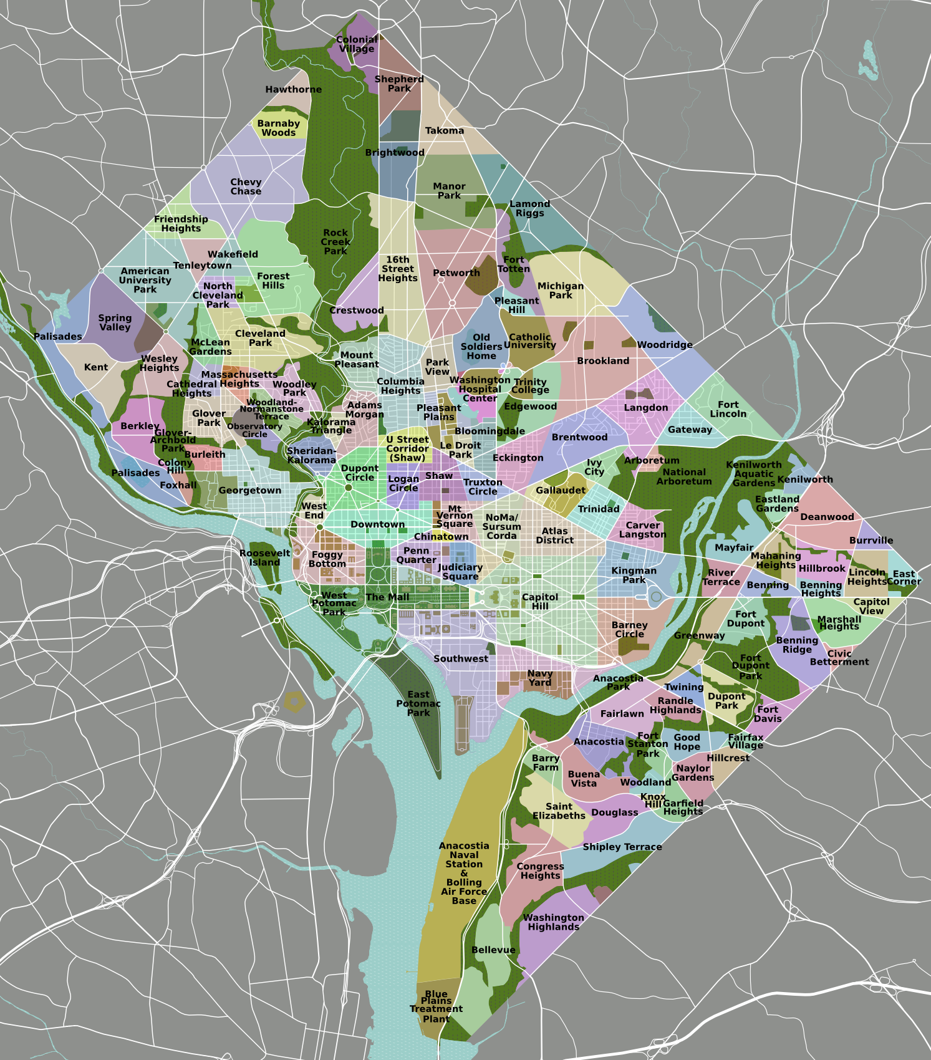
Northern Virginia Suburbs (Rosslyn, Ballston, Tyson’s Corner, Alexandria, Clarendon etc.)

Basic Orientation of Washington DC

Like Portland, Washington’s streets form a grid with northeast, northwest, southeast and southwest quadrants; but the great majority of the population is in the northwest quadrant. The middle of both axes is the Capitol; east is divided from west by North and South Capitol Streets; south from north by Capitol Street to the east of the Capitol and the National Mall west of the Capitol. Most of the District’s streets are laid out in a grid, with north-south streets numbered, the numbers getting larger as you go further from North and South Capitol. East-west streets have names that run from A to W (or, between the streets with letter names, one-syllable names from A to W) as you go north or south from East Capitol and the Mall; after the “first alphabet” comes the second alphabet: two syllable street names from A to Y; then the three-syllable alphabet; and finally, at the very northern end of Northwest DC are streets named after trees, shrubs and flowers, again running from A to about L. The diagonal streets are avenues, almost all named after states. And the street numbers begin with 1 next to the axes and go up 100 with every block away from the axes. So for any street name and number, with the quadrant, you can get a good sense of about where in the District any given address is located.

DC was mostly a sleepy southern town until the federal government’s vast growth during the New Deal and World War II; it was also a heavily African-American city, with a large middle class bemoaned by the Leadbelly song “Bourgeois Blues.” Only in the most census has the black majority been reduced to plurality status. Two major dividing lines with significant class and racial significance are the Anacostia River, which divides the two overwhelmingly Black 7th and 8th wards from the rest of DC, and Rock Creek Park, which divides the generally upper middle-class and largely white upper Northwest from the rest of the city. Except for the neighborhoods west of Rock Creek Park or, at least, west of 16th Street, as well as the part of Capitol Hill huddled near the Capitol Building, most of the District’s white population left for the suburbs after the 1968 riots that followed immediately after the assassination of Martin Luther King; The past few decades, however, this pattern has been reversed with wealthier people moving back into the DC, and young professionals coming from elsewhere preferring to live in the city. As a result, gentrification has been creeping eastward both from 16th Street and northward and eastward from the immediate environs of the Capitol. Housing has concomitantly become more expensive in previously affordable neighborhoods, and poorer people as well as much of the African-American and Latino population have been pushed out to the suburbs.

The areas south of Massachusetts Avenue in northwest DC, along North and South Capitol Streets within several blocks of the Capitol as well as immediately south of the Mall in Southwest DC, form the great part of DC workplaces. The federal government is by far the largest employer, followed by the various trade groups, consultants, lobbyist, lawyers and others whose business largely involves dealing with the federal government; tourism is another dominant industry in the area. DC has a huge amount of excellent housing stock, including apartment buildings, row houses, and, in the outer portions of the District, detached houses of varying sizes.

At the present time, the neighborhoods that are at the same time the most affordable and the most appealing for recent graduates, due to the fact that lots of students/interns/young professionals live there, and are these areas that are relatively close to the working areas of the District: contiguous to each other in the northeast quadrant, relatively close to the Capitol, H Street NE and NoMa, and contiguous to each other in the northwest quadrant but a bit further away from the working areas, Columbia Heights, Petworth, and Mt. Pleasant.

What follows are a series of sketches of groupings of some neighborhoods of DC that are popular with students and young professionals.

East of rock creek: Adams Morgan, Mount Pleasant, Columbia Heights, Pleasant Plains and petworth

These neighborhoods are just north of the DuPont Circle and east of Rock Creek Park in Washington DC, and one of the advantages of living here is that you can actually walk to work to offices in downtown DC, or commute with a very short bike ride. Several major bus lines, both the Metrobus system and the less expensive Circulator buses) run through the area (one bus-line, the 42, terminates in Mt. Pleasant), as do Metro’s Green and Yellow Lines; the Red Line is a reasonable walk from the westernmost neighborhoods as well. The neighborhoods are up a steep hill from U Street; from the southern edge of the neighborhoods you can see all the way to the Washington Monument and even beyond to the Potomac River. In fact, the 13th Street side of Cardozo High School and the southern end of Meridian Hill Park (between 15th and 16th Streets, it is known to ling-time neighborhood residents as Malcolm X Park) are favorite spots for neighbors to watch the July 4 fireworks. The southern end of Malcolm X Park also has a thirty-year-old drummers’ circle that begins late Sunday afternoon and goes into the evening. There are commercial strips in these neighborhoods that include both excellent bars and restaurants, as well as more neighborhood-y places. Until the 1980's, these neighborhoods were the center of Latino life in the District, and a large number of restaurants and small shops remain from that period; many Latinos still come into the neighborhood to shop and hang out on weekends. The neighborhoods have been slowly gentrifying since the mid-1970's in Mt. Pleasant and Adams Morgan, and since the 1990's in Columbia Heights; the gentrification of Pleasant Plains (the eastern edge of Columbia Heights), has only started in the last several years.

Housing in this group of neighborhoods features varying mixtures of row houses and apartment buildings. Most of the row houses are single family homes with “English basements,” which means that the ground floor is below ground but there are windows in the front and back of the apartments – because the area tends to be sloped from south to north, one end of the apartment is often at the ground floor level. These “English basements” are easily the most affordable housing in the area, although there may be little light coming in the windows at one end of the apartment. Also highly affordable are rooms in some of the row houses that have been rented as group houses. Both large and small apartment buildings are divided among entirely rental, condominiums and even coops (in apartment buildings whose units were sold off around the time of World War II). There is a fair amount of new housing construction in the area, much of it condominiums.

Mt. Pleasant
Generally speaking, the quietest and most affordable housing in this group of neighborhoods is to be found in Mt. Pleasant; it also has the smallest fraction of the housing in the form of apartment buildings – largely along Mt. Pleasant Street and eastward to 16th Street. West of Mt. Pleasant Street is mostly row houses, and large number of those row houses are still available as group houses; a smaller number have been divided into apartments, generally with one apartment per floor. The one commercial strip in Mt. Pleasant is along Mr. Pleasant Street, where there are restaurants, bodegas and small supermarkets, and retail stores. There is a nice farmers market on Saturday mornings in the plaza located at Mt Pleasant and Lamont Streets, at the turnaround for the 42 bus line. It is a long walk from Mt. Pleasant across Rock Creek Park to the Cleveland Park commercial strip, and a shorter walk to the Columbia Heights and Adams Morgan shopping and nightlife areas. Mt. Pleasant also has one of the area’s two (very busy, newly modernized) public libraries. Mt. Pleasant has close and easy access to Rock Creek Park.

Columbia Heights
Columbia Heights is the next most affordable part of this group of neighborhoods, although significantly lower prices can be found in the far northern part of Columbia Heights as well as the eastern section of the neighborhood, known as Pleasant Plains – here the houses are tiny, often with as few as two bedrooms. The main commercial area of the Columbia Heights neighborhood runs along 14th Street from Irving Street north to about Monroe Street; this includes some big box stores, a very ample (and usually very crowded) Giant Foods supermarket, as well as restaurants and bars. There are a few restaurants, bars, and bodegas along Park Road and 11th Street as well. There are significant numbers of apartment buildings along 16th Street, 15th Street, and 14th Street, as well as on 13th Street at the southern end of Columbia Heights; some of these buildings are public housing. The rest of the neighborhood is mostly row houses, although many of these have been recently been broken up into condominiums. At the heart of the neighborhood at 14th and Irving Streets is the Columbia Heights Metro Station on the Green and Yellow Lines.

Adams Morgan
Adams Morgan is the most expensive in this group of neighborhoods; it is a hodgepodge of row houses and apartment buildings; the major thoroughfare of Columbia Road is entirely lined with tall apartment buildings; but there are apartment buildings mixed in with the row houses throughout the other streets of the neighborhood. It has several sub-neighborhoods – Reed-Cooke south of Columbia Road (named for the two elementary schools located within it) and east of 18th Street has the most affordable housing; Lanier Heights north of Columbia and squeezed between Calvert Street and Rock Creek Park is the next most affordable, partly because there are still a few group houses in this area (along Adams Mill Road are a handful of detached houses overlooking Rock Creek Park and the National Zoo; from some parts of Lanier Heights you can hear the lions roaring and the gibbons calling in the early morning hours). From Lanier Heights you can walk into the back of the National Zoo or on Beach Drive, which runs up through Rock Creek Park and which many people in the neighborhood use as a running track. The most expensive part of the Adams Morgan neighborhood is west of 18th Street, and especially the Kalorama neighborhood sandwiched between Calvert Street, Columbia Road, and Connecticut Avenue.

Adams Morgan features two large supermarkets, the Safeway along Columbia Road and the Harris Teeter in the Reed-Cooke area; the main commercial strips are Columbia Road and 18th Street, which has been a major center for DC nightlife since the 1970's. There is a Saturday farmers market in the plaza at the intersection of 18th and Columbia. Neighborhood parks include Walter Pierce Park on the western side of Lanier Heights, which includes a popular dog park, Kalorama Park along Columbia Road, and the fields of the Marie Reed Early Childhood Education campus which includes a pair of tennis courts and a neighborhood swimming pool.

Petworth
Located directly north of Columbia Heights, Petworth has more affordable housing units than its surrounding neighborhoods. It is served by the Petworth metro stop (Green and Yellow), which has a large Safeway just north of the station serving the neighborhood. Petworth is popular for students and young professionals due to its many large group houses with affordable prices, with rooms available for $700 upwards. Both Georgia Avenue and Upshur Street have several bars and restaurants, with the latter hosting the popular Upshur Street Bookstore. The neighborhood’s recently renovated public library is located a few blocks north of the Metro station.

North of Downtown: Bloomingdale, Eckington, Park View,
Shaw, and U Street

These neighborhoods are all very close to major thoroughfares in DC, including New York Ave., Rhode Island Ave., and North Capitol Street. This puts you in close proximity to major bus lines that take you downtown as well as several metro stop options (mostly along the Green and Yellow lines). However, these major streets often carry heavy traffic and generate congestion, which can make them difficult for pedestrian use.

Bloomingdale & Eckington
These two neighborhoods are mostly residential and are based around the intersection of Rhode Island Avenue and North Capitol. While they are mostly quiet, there has been a recent spate of development, bringing bars, restaurants, and other amenities. Every Sunday, Bloomingdale hosts a popular farmer’s market on R St. and 1st St. NW that includes produce from regional farmers as well as other services such as self-help bike mechanics. Big Bear Café serves as a popular meeting spot for the neighborhoods and often hosts talks and art exhibitions. Rent prices tend to be comparable to other gentrifying neighborhoods, with a one bedroom English basements starting at around $1,300.

Shaw & U Street
Located directly west of Bloomingdale, Shaw (which contains the lively U Street Corridor) is a densely populated neighborhood that is home to a vibrant nightlife and many restaurants. With many Victorian row houses and small parks, including LeDroit Park, Shaw has a strong sense of community and deep connection with Washington DC’s African American history. At the same time, Shaw has had a recent uptick of reported theft and other crimes (including shootings), which have been well-publicized and has lead to mobilization from the neighborhood’s residents to discuss the issue. Because Shaw has been one of the hearts of DC’s African American population, as well as due to its proximity to Howard University, gentrification has become an especially contentious issue for Shaw’s residents. The U Street Corridor is a very popular street for night clubs, restaurants (including many of DC’s Ethiopian and Eritrean eateries), and storied music venues such as 930 Club and Velvet Lounge. Rent prices tend to be more expensive than its more eastern neighbors (Bloomingdale, Near Northeast etc.) but there are many nearby amenities, such as a Trader Joe’s and other supermarkets.

Park View
Park View is a small neighborhood nestled below Petworth and to the east of Columbia Heights. The park refers to the Armed Forces Retirement Home, which you can view but you cannot visit. It makes for a nice walking or jogging route, along Rock Creek Church Road past Lincoln's summer home, which you can visit, and into the peaceful and historic Rock Creek Cemetery. If you are more interested in nightlife, the neighborhood is accessible to some happening blocks of 11th Street NW, a growing strip of bars along Georgia Avenue emanating from the Petworth metro, and the hip establishments of Upshur Street NW. Cultural attractions include Dojo Comedy on Georgia, the Bloombar on 11th, and the Sankofa Café and bookstore and Pleasant Plains arts workshop along Georgia in the direction of Howard University. The neighborhood is thoroughly mixed demographically, including middle class families, the unemployed poor, Howard students, University of Maryland graduate students, Central American immigrants, and newcomer yuppies paying $750K for renovated luxury row houses.

Near Northeast and Southeast DC: Capitol Hill, H Street Corridor, NoMa and Trinidad

The neighborhoods in Northeast DC have experienced rapid gentrification recently and very rapidly but are still more impoverished than their NW neighbors. With the exception of Capitol Hill, which is historic neighborhood with a tradition of historical preservation, much of H street NE, NoMa, and Trinidad (collectively Near Northeast) spent many decades in disrepair, and only recently have gentrified at a rapid pace, pushing out its poorer residents. Luxury apartments with one bedrooms starting at $1,800 dot the H street Corridor; affordable housing in many of the row-houses in NE DC is still available, but rapidly diminishing.

Capitol Hill
Capitol Hill, like many other D.C. neighborhoods, itself is made up of many smaller sub-neighborhoods. Most generously, the Hill is bordered by the Anacostia and Potomac rivers to the east and south, H St. NE (itself now a desirable retail if not entirely residential area) to the north and the Capitol rotunda to the west. Some neighborhoods on the Hill, particularly on the eastern edges, used to be known for being inexpensive if not necessarily safe, but that dynamic has flipped thanks to gentrification as well as reduced crime. Now, crime is generally low to moderate but housing is moderately to very expensive.

Eastern Market
Eastern Market is the heart of Capitol Hill. Mainly comprised of row-houses and small apartment buildings, there are restaurants galore in the area as well as Metro stations on the silver/orange/blue lines. These stations serve most other areas on the Hill, with some neighborhoods also close to Union Station which is on the red line and also has an Amtrak station as well as MARC which serves the Maryland suburbs.

Hill East
Hill East includes a number of neighborhoods between Eastern Market and RFK Stadium, some more affordable than others and generally more affordable than Eastern Market. It includes Lincoln Park, one of the larger parks on the Hill, and some larger condominium buildings such as the Car Barn. Some such condos are for rent, while others are for sale, and prices have been rising over the years. Hill East also includes Congressional Cemetery, where events like movie screenings are held and famous people (J. Edgar Hoover, etc.) are buried.

There is also the Barracks Row neighborhood, which is better known as host to more than a dozen restaurants and many small shops, as opposed to a place with many places to rent. Barracks Row gets its name for the Marine barracks.

H Street NE Corridor
This neighborhood spans eastward from 3rd St. NE (walking distance to Union Station and NoMa metro) to all the way to 15th St. NE. While H St will ultimately be served by a Streetcar, most of H St. is connected to downtown DC by several buses. There are many restaurants showcasing international cuisine clustered on H street, including Indigo and Cusbah for South Asian food, Ethiopic and Sidamo for Ethiopian food, Toki Underground and Maketto for East Asian food. Additionally, this is a lively place for night clubs and music venues such as Rock and Roll Hotel, the Argonaut, and Little Miss Whiskeys. However, many of the businesses are located on the eastern edge of the neighborhood, making them inaccessible to metro. The H Street Corridor is served by a Giant supermarket on H and 3rd NE, and a Safeway off H and 15th NE. With the influx of large luxury apartment complexes, rent prices have increased substantially over the past few years. However, English basements and small row-houses are still popular for young people, with prices generally more affordable north of H street.

NoMa
Standing for North of Massachusetts Avenue, the NoMa is a relatively new residential neighborhood immediately north and east of Union Station. While much of the neighborhood was historically industrial, with many warehouses in the area, the city has consciously developed the neighborhood to include office spaces and residential buildings. Presently, one issue for NoMa residents is the lack of open spaces and parks, which has prompted the development of a new park on L and 2nd Street NE. NoMa is served by the NoMa-Gallaudet metro station (Red Line) and various bus lines. Harris Teeter has a large grocery store in the neighborhood. On the northern edge of NoMa lies the Warehouse District, which has many shops selling international grocery foods and produce. Union Market, a large upscale open-space warehouse, features many food and drink vendors, and oftentimes hosts musical and arts/culture events. Rent prices are somewhat cheaper than Capitol Hill and the H Street Corridor, but luxury apartment complexes are increasingly taking over the area.

Trinidad
Trinidad is a small neighborhood in the far northeast part of the H St. Corridor. A largely residential neighborhood, Trinidad is comprised of Victorian row-houses and flat porch-fronted houses and has fewer luxury apartment complexes than its surrounding neighborhoods. the neighborhood faces Gallaudet University, with Florida Ave. and Bladensburg Ave. serving as major streets for its residents. Trinidad is not served by any metro station, with both Union Station and NoMa metro a 20 minute walk away. While crime has been an issue for Trinidad residents but, much like the rest of Northeast DC, there has been a significant decline of crime in recent years. Trinidad is close to the National Arboretum and Kenilworth Aquatic Gardens, two large parks that allow for many miles of jogging and cycling. Rent in Trinidad is somewhat cheaper than NoMa and the H St. Corridor, with one bedrooms available starting at $1,100.

Northern Virginia Suburbs

Rosslyn
What amounts to "downtown" Arlington is located in Virginia just over the Key Bridge from Georgetown. As the urban business center of Northern Virginia, most housing is available in high rise apartment buildings. In order to maintain a sense of urban community, Rosslyn hosts such annual events as the Washington, DC, Independent Film Festival and the Rosslyn Jazz Festival. There are extensive walking/biking trails located along the Potomac River. With ever-burgeoning development centered around the numerous Metro stations, there is a growing bar and restaurant scene that, along with arts and entertainment, accommodates young professionals who like the convenience of being close to DC.

Ballston
Numerous high rise apartments and office buildings are mixed with single family homes further north and south. The area is host to the annual Taste of Arlington Food Festival, as well as Ballston Common Mall. As is typical with Arlington, development is highly concentrated around the Metro station. The region is highly walkable, with numerous dining options available.

Tyson’s Corner
With the recent extension of Metro out to the Tyson's Corner area and beyond, development in the area has exploded. While the promise of walkability and pedestrian friendliness has not yet (and may never) be fully met, Tyson's remains the area's largest employment center, as well as home to the region's largest shopping mall, the Tyson's Corner Mall. The area is also home to a number of first-rate restaurants. It is now possible to live and work in the Tyson's area without a car.

Alexandria
Located seven miles south of Washington, DC, Alexandria is a sprawling suburb that is a destination spot in its own right. The Old Town neighborhood is the oldest section, its historic waterfront setting a home to numerous bars, restaurants and boutiques. It is a tourist hub, with the Torpedo Factory Art Center being home to the largest collection of working-artist studios in the country. Known for its quaintness and its many cobblestone streets, it also happens to be one of the most pet-friendly neighborhoods in the region, with numerous dog parks, animal training centers, and veterinary hospitals. Walking/bike paths from Mt. Vernon pass through Old Town on their way to DC. Numerous apartment buildings, both small and large, easily mix with single family residences. The Del Ray neighborhood has been booming with bars, restaurants, and other shops, and the Birchmere is a premiere music performance space that serves dinners during performances as well. There are numerous Metro stations in the area, including King Street and Eisenhower Avenue.

Clarendon
Located between Rosslyn and Ballston on Metro’s Orange Line, Clarendon has been remade into a walkable destination spot. Recent years have seen the construction of new apartment buildings and condos. The proximity of the Arlington campus of George Mason University makes this area desirable to students and non-students alike.

